|  |  |  |  |
| --- | --- | --- | --- |
| **Name of Student: NINAD AVINASH PATIL** | | | |
| **Roll No: 33** | | **Lab Practical Number: 2.1** | |
| **Title of Lab Practical: Create an Emp(Abstract class) with eid,ename,edept & ebasicSal as DataField and two basic Functions EmpGetData() and EmpPutData(). Create an Interface called Manger with additional features as Mcar Allowance and MBonus as properties. Create a derived class(which must have CompanyName as constant and Licence No as Static). Display information depending whether he/she is a manager or not a manager.** | | | |
| **DOP: 03/03/2021** | | **DOS: 10/03/2021** | |
| **CO Mapped: CO1** | **PO Mapped: PO3, PO5, PO7,**  **PO12, PSO1, PSO2** | **Faculty Signature:** | **Marks:** |

**Practical No 2.1**

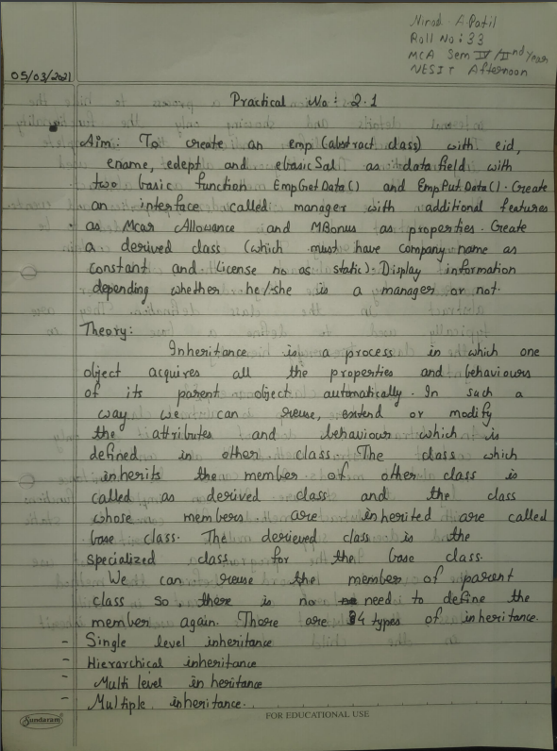

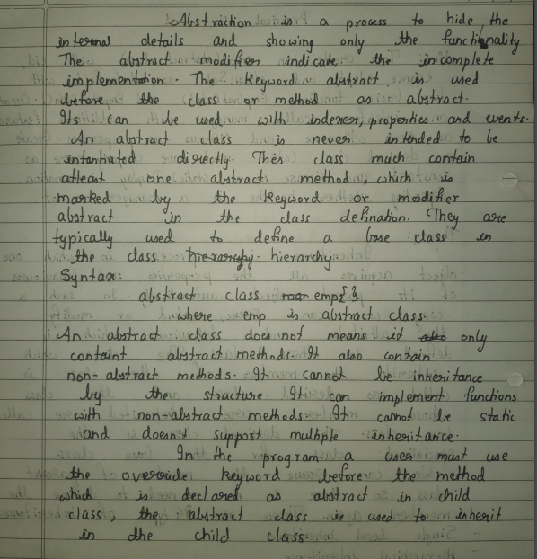

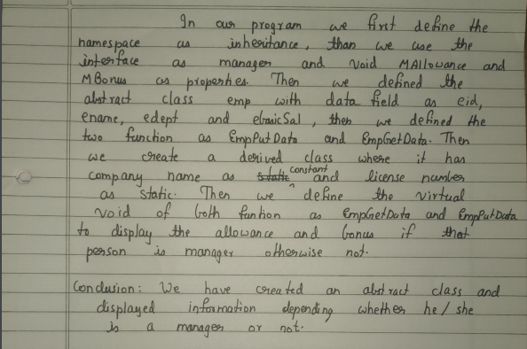

**Code:**

using System;

using System.Collections.Generic;

using System.Linq;

using System.Text;

namespace inheritance

{

interface Manager

{

void McarAllow();

void MBonus();

}

abstract class Emp : Manager

{

public Int32 eid,bonus,allowance;

public String ename, edept;

public Double ebasicSal;

public virtual void EmpPutData() { }

public virtual void EmpGetData() { }

public void McarAllow() { }

public void MBonus() { }

}

class A : Emp

{

const String Cname="1";

static Int32 licenseno;

public virtual void EmpPutData()

{

Console.WriteLine("Company Name : " + Program.Cname);

Console.WriteLine("Licence No : " + Program.licenseno);

Console.WriteLine("\nEnter Employee ID");

eid = Convert.ToInt32(Console.ReadLine());

Console.WriteLine("Enter Employee Name");

ename = (Console.ReadLine());

Console.WriteLine("Enter Employee Department");

edept = (Console.ReadLine());

Console.WriteLine("Enter Employee Basic Salary");

ebasicSal = Convert.ToDouble(Console.ReadLine());

}

public virtual void EmpGetData() {

Console.WriteLine("\nEmployee ID: " + eid);

Console.WriteLine("Employee Name: " + ename);

Console.WriteLine("Employee Department: " + edept);

Console.WriteLine("Employee Basic Salary: " + ebasicSal);

}

public void mallow() {

Console.WriteLine("Enter The Allowance");

allowance = Convert.ToInt32(Console.ReadLine());

}

public void mbonus() {

Console.WriteLine("Enter The Bonus");

bonus = Convert.ToInt32(Console.ReadLine());

}

public void Mana()

{

Console.WriteLine("Emplyee Car Allowance is " + allowance);

Console.WriteLine("Employee Bonus is " + bonus);

}

}

public class Program

{

public const string Cname = "Oracle";

public static string licenseno = "Oracle 2021";

public static void Main(string[] args)

{

String cond; A a=new A();

a.EmpPutData();

Console.WriteLine("Are you a manager? (Yes/No)");

cond = Console.ReadLine();

if (cond == "Yes")

{

a.mallow();

a.mbonus();

a.EmpGetData();

a.Mana();

Console.ReadLine();

}

else

{

a.EmpGetData(); Console.ReadLine();

}

}

}

}

**Output:**

